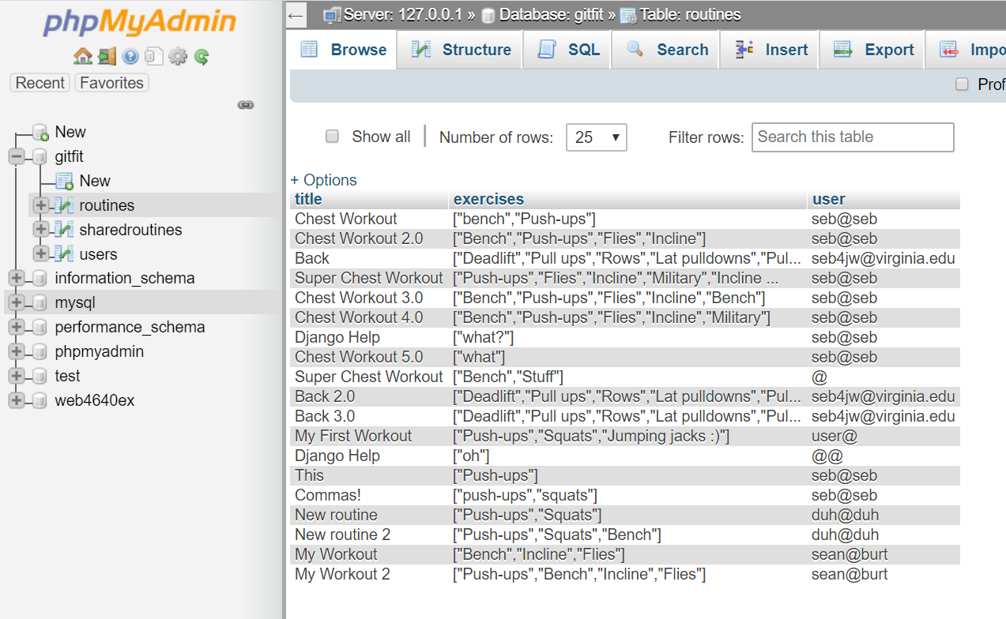**Routines Table**

As shown, it has a title (varchar(50)), exercises (varchar(1000)), and user column (varchar(50)) to store the data about each routine.

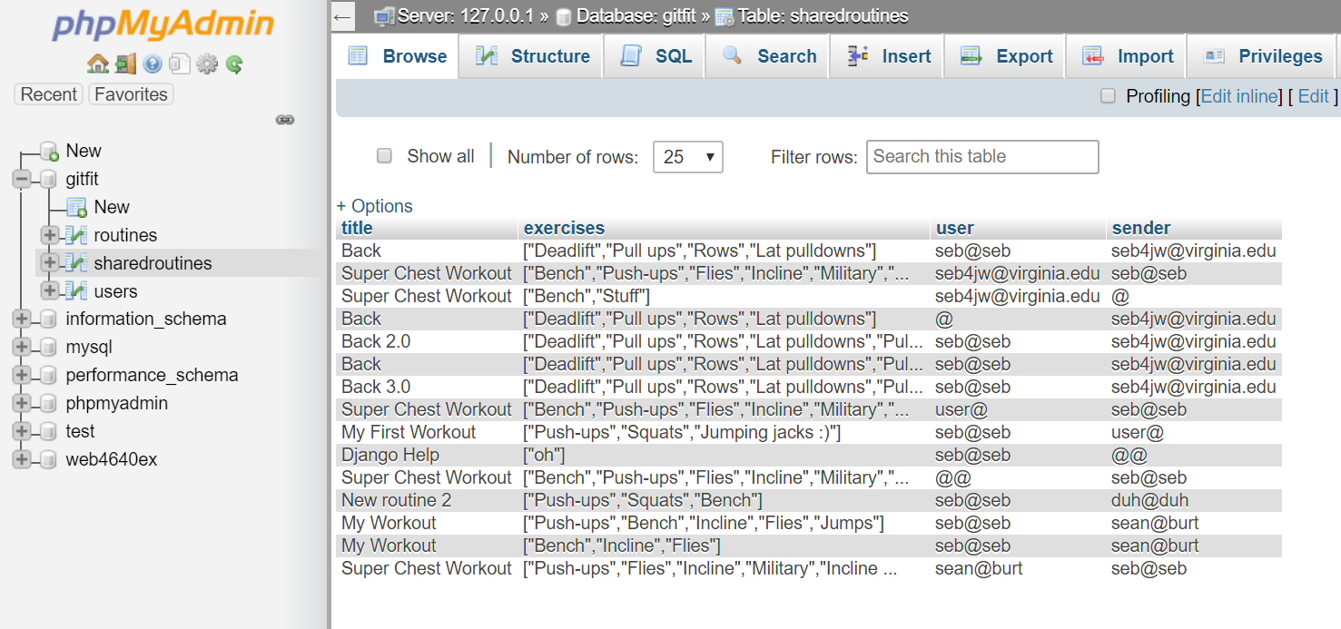**Shared Routines Table**

As shown, it has a title (varchar(50)), exercises (varchar(1000)), user (varchar(50)), and sender column (varchar(50)) to store the data about each shared routine.

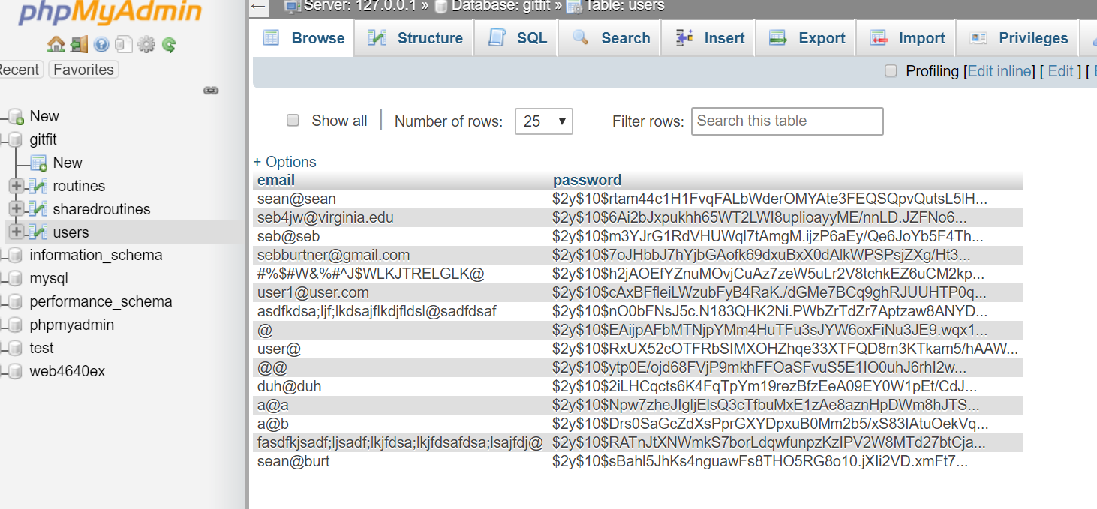**Users Table**

As shown, it has an email (varchar(50)) and password column (varchar(255)) to store the data about each user.